**USE CASE: Define delegate**

Document History

Document Location

This is a snapshot of an on-line document. Paper copies are valid only on the day they are printed. Refer to the author if you are in any doubt about the currency of this document.

The source of the document will be found …

Revision History

|  |  |  |
| --- | --- | --- |
| Revision Number | Revision Date | Summary of Changes |
| 1.0 | 6/3/2013 | Initial document |
| 1.1 | 7/15/2013 | Revised- Q&A section added |
|  |  |  |
|  |  |  |

Approvals

This document requires following approval signature. Signed approval forms are filed in …

|  |  |
| --- | --- |
| **Name** | **Title** |
|  |  |
|  |  |
|  |  |
|  |  |

Distribution

This document has been distributed to:

|  |  |
| --- | --- |
| **Name** | **Title** |
|  |  |
|  |  |
|  |  |
|  |  |

Contents

1. Introduction 4

1.1 Purpose 4

1.2 References 4

1.3 Notation/Structure 4

2. Use Cases 4

2.1 Use Case Name 4

2.1.1 Use Case Overview…. 4

# Introduction

Use Cases are detailed descriptions of how users and systems interact with an application. These descriptions include ideal paths with alternate paths and post conditions. This information assists the structure and interface design for the best possible experience for the site’s users. Additionally, the Use Cases are used by the QA team to ensure all objectives and requirements were met and fulfilled successfully.

A set of Use Cases can be created to describe the majority of user interactions with the application. The Use Case will ultimately drive the User Experience team in defining the interface. With a clear distinction between user and system interactions written in use case form the UI can be developed in more detail.

Each Use Case follows and tracks back to business requirements.

## Purpose

This document describes the Use Cases for the outlined system.

Use Cases are used to explore and communicate the likely actions of users and the system when interacting with the application. Development of Use Cases helps the design team understand the business requirements and how they can ultimately drive the design and user experience.

## References

This document is based on the following documents:

* Document Name

## Notation/Structure

Use Cases typically have the following sections:

1. Overviews
2. Preconditions
3. Triggers
4. Main Flows
5. Alternate Flows
6. Business Rules
7. Messages (system generated)

# Use Cases

## Use Case Name: Define delegate

### Use Case Overview….

|  |  |  |
| --- | --- | --- |
| **Use Case ID** | **Define delegate** | |
| **Use Case Overview** | A user can define a delegate- another user that the user authorizes to provide opinions or decisions on their behalf. A user might define a delegate because they are going to be on vacation, or anticipating being unavailable for an extended period. Only one delegate can be associated.  It is anticipated that customers will want more granularity to associate a variety of delegates depending on the master document and situation. These capabilities are not in scope, but may be considered for future releases. | |
| **Precondition** | 1. User is logged in   It is anticipated that customers may want to be able to authorize the use of delegates at the system level, and/or only allow delegation for certain roles. These capabilities are not in scope, but may be considered for future releases. | |
| **Trigger(s)** | 1. User selects "Manage Delegation" (Personal Setup/Manage Delegation). | |
|  | | |
| **B - Main Flow** | | |
|  | B1 | System displays user data form titled "Manage Delegation". The page contains an informational disclosure that reads as follows: "You can set a delegate for opinions you are asked to provide and decisions you are asked to make. Authorizing a delegate can be appropriate when you plan to be unavailable for extended periods of time and when your delegate is someone you trust to make the types of decisions you're asked to make in Cosentium. All opinions and decisions provided by your delegate will be stamped "..by <delegate full name> on behalf of <your full name>." For the duration period you select, When you have assigned a delegate and set a duration, your delegate will be asked to provide all opinions and decisions requested from you until the duration expires. You will be copied on all the document review requests that go to your delegate.  Display two columns, the first with heading "Delegate To", the second with "Duration".  Underneath the "Delegate To" column header, if the user has previously selected a delegate, that user's name shows. By default, the field shows an entry of "None Selected". The user can also access a list of users to select a different delegate. If the user wants to add a new user, there is a button labeled "New User" (Alternate Flow)  Underneath the "Duration" column header, if the user has previously selected a delegate and defined a duration that has not yet expired, the user's selection shows as "Expires dd/mm/yyyy". By default, the field shows an entry of "None Selected". The user can select from a drop down list of possible durations. The possible durations are:  1 day; 2 days; 3 days; 1 week; 2 weeks; 1 month;  In addition to the "New User" button, there are two additional buttons. One labeled "Save" and another labeled "Cancel" (Alternate flow) |
|  | B2 | User selects a Delegate and Duration using the drop down selections. |
|  | B3 | User clicks "Save"  System does validation as follows:  Delegate has an entry, but Duration does not. This passes validation (user may want to designate a delegate, but does not currently want to delegate anything to him/her).  Delegate has an entry, and Duration also has an entry. This passes validation.  Delegate does not have an entry and Duration also does not have an entry. This does not pass validation. Redisplay B1 with red highlighting next to the field(s) that need to be corrected/completed, along with M2 informative text in red to help the user know how to correct.  Duration has an entry, but Delegate does not. This does not pass validation. Redisplay B1 with red highlighting next to the field(s) that need to be corrected/completed, along with M2 informative text in red to help the user know how to correct. |
|  | B4 | System displays page, "Manage Delegation". The page now displays M1, ("changes saved") at the top. The "Delegate To" column now displays the current delegate full name. The "Duration" column now displays (Expires dd/mm/yyyy)" or "None Selected". |
| **Post-**  **conditions** | * Updated/Modified user account | |
|  | | |
| **A1** | **Cancel** | |
|  | A1.1 | User selects "Cancel" |
|  | A1.2 | System displays page, "Personal Setup" |
| **Post-**  **conditions** | * No modifications to user account | |
|  | | |
| **A2** | **New User** | |
|  | A2.1 | User selects ‘New User. |
|  | A2.2 | Deliver user to "main flow" of the "add a user" use case document. |
|  | A2.3 | After user completes the "add a user" process, deliver the user back to define delegate, main flow, step B1. |
| **Post-**  **conditions** | * New user added * User returned to the Define Delegate main flow, B1 * The new added user is available to be selected in the Define Delegate main flow, B2 | |
|  | | |
| **Messages** | M1 | "Changes Saved" |
|  | M2 | "You must enter a value" |
|  | M3 |  |
|  | M4 |  |
|  | M5 |  |
|  | | |
| **BRs** | BR1 |  |
|  | BR2 |  |
|  | BR3 |  |

Q&A

|  |  |  |  |
| --- | --- | --- | --- |
| **Question** | **Question Date** | **Answer** | **Answer Date** |
| In the “managedelegation1.png” there is a provision for adding a “new user” in the system but as per the roles and permissions deck only **“System Admin” and “Doc Admin”** can add a new user? Please clarify? | 16-07-13 | good point. We want a user to specify a user that can be their delegate, and not have a bunch of friction slowing down the creation of a new user that does not exist. How about we allow a user to add a user to be their delegate, if they do not already exist in the system, but if the user that is adding the new user is not a sys admin or doc admin, then the new user can only have very basic permissions ("basic permissions" needs definition, I know). | 17-07-13 |
| We can keep the Duration drop down values in the **“days”** format only instead of weeks and months as this will keep the things clean (confusion in case of months) for everyone in the system. Please confirm? | 16-07-13 | Ok | 17-07-13 |
| During the duration of the delegation the notifications (related to delegated user) should be sent to both the actual owner and the delegated user as well. Please confirm? | 16-07-13 | yes, the actual owner should be cc'd | 17-07-13 |
|  |  |  |  |

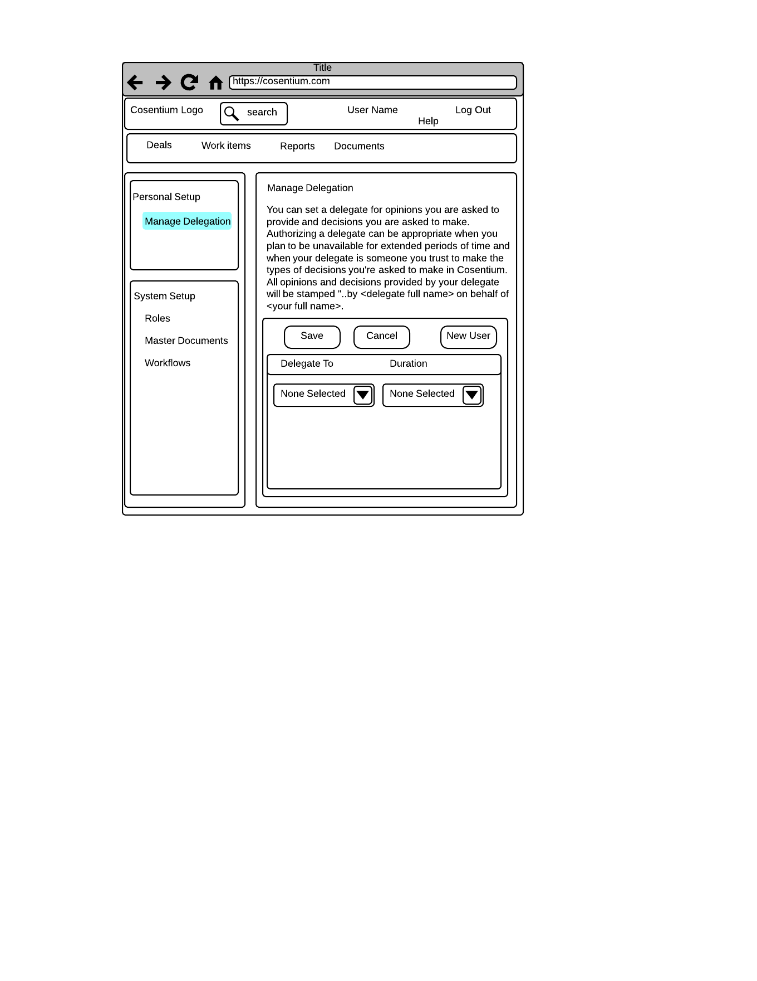

VR1: "managedelegation1.png"

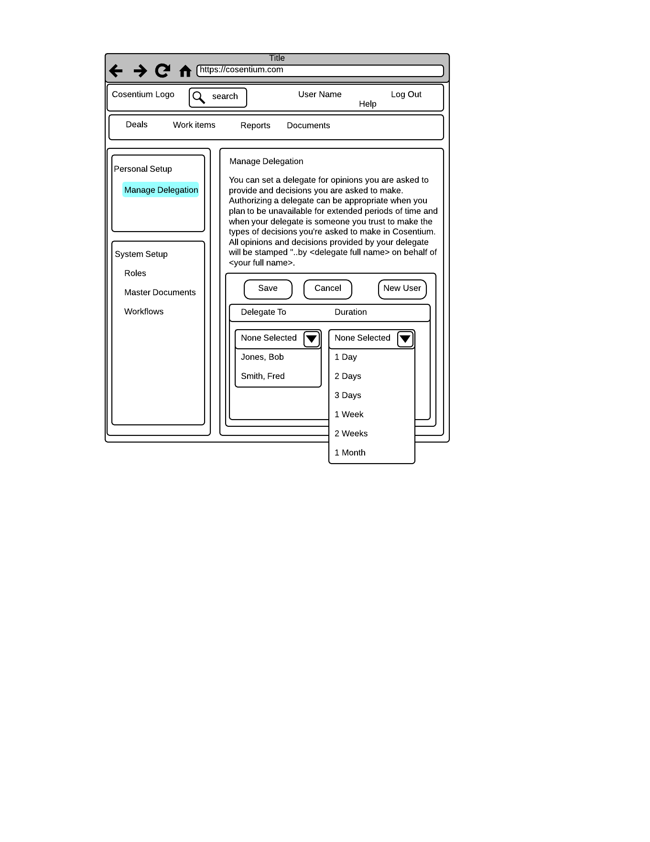

VR2: "managedelegation2.png"

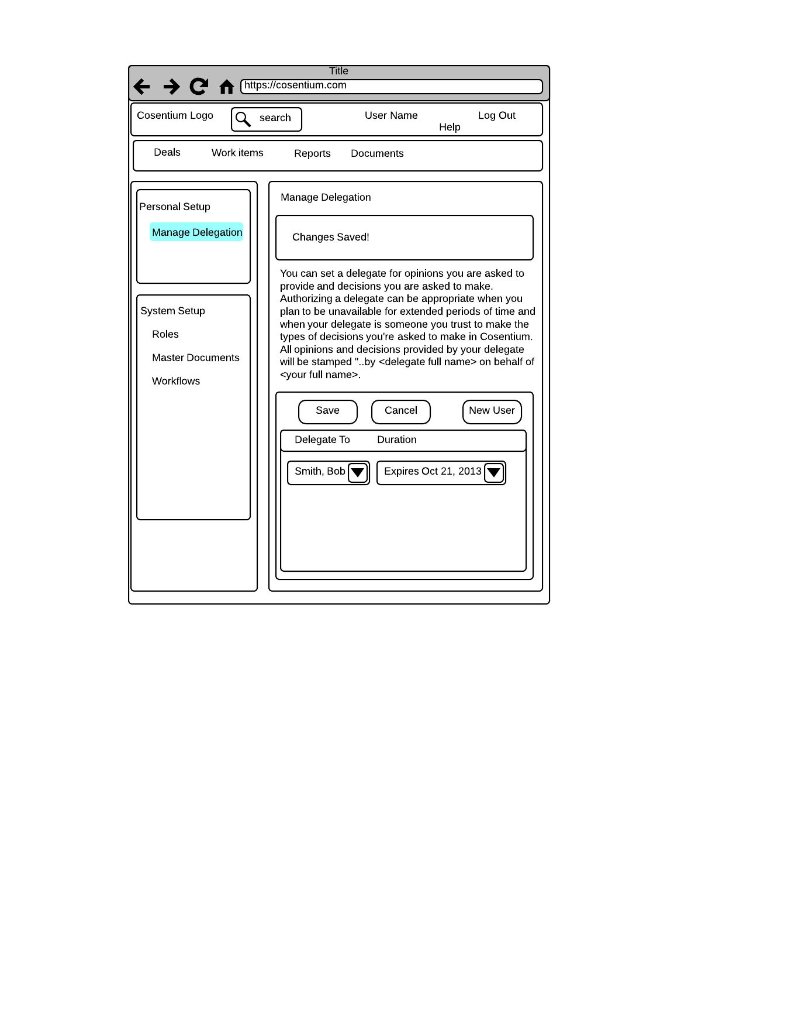

VR3: "managedelegation3.png"